A QR code will be posted on August 20, 2025 to register for tryouts and be 100% sure your child is cleared through [www.aktivate.com](http://www.aktivate.com) before she arrives for tryouts! Thank you!!

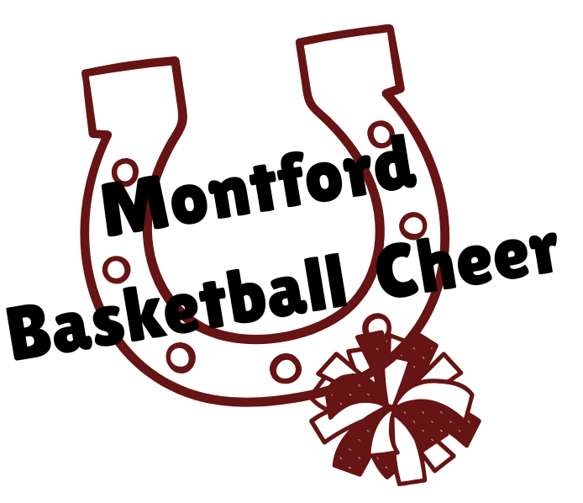

FAQs about Cheer Tryouts!

1. So, I hear there are going to be two cheer teams at MMS, what’s that about?

That is correct!! More opportunities for more kids to support Montford athletics!! There will be a football cheer team AND a basketball cheer team. Football season runs August – October (about 8 weeks) and Basketball season has eight games between October - February. There will be one tryout for the football team in July and another tryout for the basketball team in September. Athletes can participate in either team or both teams! Each cheer team will have separate seasons, but practices will start right away and may be combined with both teams from time to time!

1. What do I need to do to tryout?

Complete the Registration process on Microsoft Forms on our website!

1. **Complete your child’s registration at** [**https://www.aktivate.com/**](https://www.aktivate.com/) **BEFORE September 12**!
2. Attend the tryout clinic September 16-17 from 4:00 – 5:30pm in our cafeteria.
3. Tryouts will begin at 4:00 on Thursday, September 18th!
4. What do I need to wear?

For the three clinic days, you need a sports bra, T-shirt or tank top, athletic shorts, tennis shoes and your hair pulled up out of your face. We will put a number on your leg each day, so you’ll need to be in shorts all four days.

*For the tryout day, you’ll need all the above, but your shorts will need to be black, and your shirt will need to be a white tank top.

1. What do I need to be able to do for tryouts?

You will be taught two cheers, and a cheer dance on the two days of the clinic. These will not be posted online, so it’s important you attend both days of the clinic. Each candidate will also be asked to show the judges a toe touch.

1. Do I need to be able to tumble to try out?

You do not need to be able to tumble, but those who do typically score higher at tryouts!

Tumbling consists of a standing back handspring or standing tuck, and running tumbling could be a roundoff to back handspring, or multiple back handsprings or to a tuck or layout. (Cartwheels, roundoffs and aerials are not considered tumbling…) If you do not tumble, you will be asked to do a hurdler jump instead.

1. When do I find out if I made the team? We will post the numbers of the athletes who made the team Thursday night on our website along with additional information for the season!
2. What if I am unable to attend the clinic / tryouts on September 16-18? You will have an opportunity to try out again next year!
3. What do my grades have to be? If you are worried about this question, you probably should not try out. Academics will always come first and then cheerleading. We pull grades each game week and if you have any Fs, you are not allowed to dress out at school on the game days nor participate in the game that night.
4. What about behavior at school? Cheerleaders are always held to a higher standard than other kids at the school – it’s just the way it is so your behavior is very important to us! Everyone makes mistakes and we understand that, but multiple behavioral consequences (lunch detentions or In School Suspension) will result in removal from the team. An Out of School suspension is an automatic removal from the team for the rest of the season. This is completely preventable so just make good choices, do your schoolwork and listen to your teachers and you’ll be fine! 😊
5. How much does it cost to be a Montford Cheerleader? Each year the fees are a little different, but it’s roughly $400.00 dollars. Returning girls don’t usually need to purchase poms or the shorts that go under the uniforms, so their cost is less.
6. When are cheer practices – They are BEFORE school one to two mornings a week from 8:00 – 9:00am.
7. Are there any weekends required? There are two weekends required for the football cheer team and one Saturday for the basketball team this year! The date for Basketball Cheer is 10/4/25 at Cheer Nation from 9:00-3:00.

We perform at several events outside of the season games – Winter parade, Breast Cancer Awareness events, Mustangs United event, and the LCS Middle School Showcase.

There are many high school girls who would love to make a little extra money to help you!! Feel free to reach out to them if you’re interested in this. Good luck and we look forward to seeing everyone at the clinic on September 16th at 4:00pm!!.

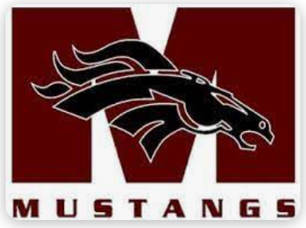

GO MUSTANGS!